|  |  |  |  |
| --- | --- | --- | --- |
| **S.NO.** | **DATE** | **TITLE** | **PAGE NO.** |
| 1 | 31-01-2025 | **Develop Python programs using simple Input/Output operations** |  |
| 1.1 |  | Printing your Name | 3 |
| 1.2 |  | Printing your Age Next Year | 4 |
| 2 | 31-01-2025 | **Develop Programs using operators and expressions** |  |
| 2.1 |  | Convert Celsius to Fahrenheit | 5 |
| 2.2 |  | Find Simple Interest | 6 |
| 3 | 07-02-2025 | **Write Python programs using control statements** |  |
| 3.1 |  | Leap Year or Not | 7 |
| 3.2 |  | Day of the Week | 8 |
| 4 | 07-02-2025 | **Develop Python programs to generate series and patterns using control statements** |  |
| 4.1 |  | Hollow Star Pyramid | 9 |
| 4.2 |  | Fibonacci Series | 10 |
| 5 | 14-02-2025 | **Develop Python programs using simple functions and recursion** |  |
| 5.1 |  | Sum of First N Natural Numbers | 11 |
| 5.2 |  | G.C.D. of Two Numbers | 12 |
| 6 | 14-02-2025 | **Write Python programs for operating on strings and string handling functions** |  |
| 6.1 |  | Count of different characters in a string | 13 |
| 6.2 |  | Reversing each word in a sentence | 14 |
| 7 | 28-02-2025 | **Develop Python programs using Lists, Nested Lists, and List Comprehensions** |  |
| 7.1 |  | Rotating a list | 15 |
| 7.2 |  | Filtering a list | 16 |
| 8 | 14-03-2025 | **Develop Python Programs using Tuples, Nested Tuples, and Tuple Comprehension** |  |
| 8.1 |  | N number of minimum and maximum values | 17 |
| 8.2 |  | Flattening a nested tuple | 18 |
| 9 | 21-03-2025 | **Write Python programs creating sets and performing set operations** |  |
| 9.1 |  | Common Students | 19 |
| 9.2 |  | Unique Elements | 20 |
| 10 | 04-04-2025 | **Develop Python programs using Dictionary, Nested Dictionary, and Dictionary Comprehension** |  |
| 10.1 |  | Even Squares | 21 |
| 10.2 |  | Top Student by Average | 22 |
| 11 | 11-04-2025 | **Design Python programs to handle errors and exceptions** |  |
| 11.1 |  | Valid input | 23 |
| 11.2 |  | Division of two numbers | 24 |
| 12 | 11-04-2025 | **Write Python programs with multiple handlers for exceptions** |  |
| 12.1 |  | Division of two numbers | 25 |
| 12.2 |  | Square root of number | 26 |
| 13 | 25-04-2025 | **Write Python programs to read, create, and update text files** |  |
| 13.1 |  | Copy one File into Another | 27 |
| 13.2 |  | Count of lines and words in a file | 29 |

**Exp. No.: 1 Date: 31.01.2025**

**DEVELOP PYTHON PROGRAMS USING SIMPLE INPUT/OUTPUT OPERATIONS**

**1.1** – Printing your Name

Aim:

Write a Python Program to print your name

Source Code:



**Output:**



**Result:**

The Python Program to print your name has been successfully written and executed.

**1.2** – Printing your Age Next Year

Aim:

Write a Python Program to print your age next year

Source Code:



**Output:**



**Result:**

The Python Program to print your age next year has been successfully written and executed.

**Exp. No.: 2 Date: 31.01.2025**

**DEVELOP PROGRAMS USING OPERATORS AND EXPRESSIONS**

**2.1** – Convert Celsius to Fahrenheit

Aim:

Write a Python Program to convert Celsius to Fahrenheit.

Source Code:



**Output:**



**Result:**

The Python Program to convert Celsius to Fahrenheit has been successfully written and executed.

**2.2** – Find Simple Interest

Aim:

Write a Python Program to Find Simple Interest.

Source Code:

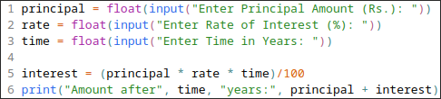

**Output:**

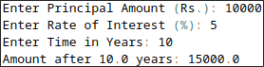

**Result:**

The Python Program to Find Simple Interest has been successfully written and executed.

**Exp. No.: 3 Date: 07.02.2025**

**WRITE PYTHON PROGRAMS USING CONTROL STATEMENTS**

**3.1** – Leap Year or Not

Aim:

Write a Python Program to Check Whether the Year is Leap Year or Not.

Source Code:

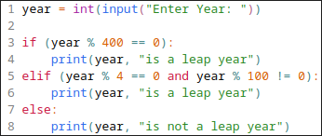

**Output:**



**Result:**

The Python Program to Check Whether the Year is Leap Year or Not has been successfully written and executed.

**3.2** – Day of the Week

Aim:

Write a Python Program to Find the Day of the Week.

Source Code:

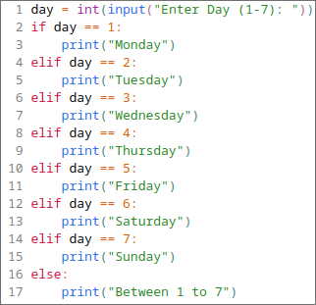

**Output:**



**Result:**

The Python Program to Find the Day of the Week has been successfully written and executed.

**Exp. No.: 4 Date: 07.02.2025**

**PROGRAMS USING FOR, WHILE, DO-WHILE LOOPS AND NESTED LOOPS**

**4.1** – Print A Hollow Star Pyramid

Aim:

Write a Python Program to Print a Hollow Star Pyramid.

Source Code:

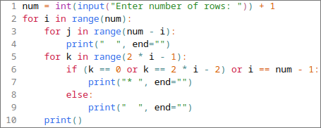

**Output:**

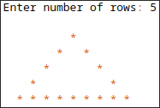

**Result:**

The Python Program to Print a Hollow Star Pyramid has been successfully written and executed.

**4.2** – Fibonacci Series

Aim:

Write a Python Program to print the Fibonacci Series.

Source Code:

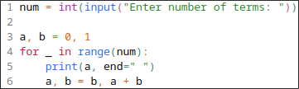

**Output:**



**Result:**

The Python Program to print the Fibonacci Series has been successfully written and executed.

**Exp. No.: 5 Date: 14.02.2025**

**DEVELOP PYTHON PROGRAMS USING SIMPLE FUNCTIONS AND RECURSION**

**5.1** – Sum of first N Natural Numbers

Aim:

Write a Python Program to find the sum of first N Natural Numbers.

Source Code:

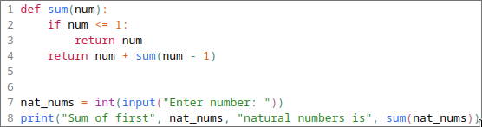

**Output:**



**Result:**

The Python Program to sum of first N Natural Numbers has been successfully written and executed.

**5.2** – G.C.D. of Two Numbers

Aim:

Write a Python Program to find G.C.D. of Two Numbers.

Source Code:

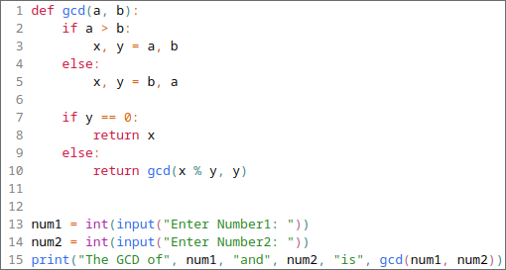

**Output:**



**Result:**

The Python Program to find G.C.D. of Two Numbers has been successfully written and executed.

**Exp. No.: 6 Date: 14.02.2025**

**WRITE PYTHON PROGRAMS FOR OPERATING ON STRINGS AND STRING HANDLING FUNCTIONS**

**6.1** – Count of different characters in a string

Aim:

Write a Python Program to count different characters in a string.

Source Code:

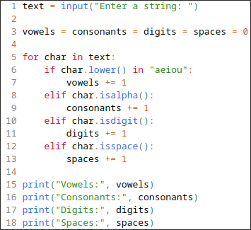

**Output:**

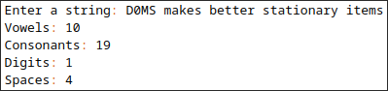

**Result:**

The Python Program to count different characters in a string has been successfully written and executed.

**6.2** – Reversing each word in a sentence

Aim:

Write a Python Program to reverse each word in a sentence.

Source Code:

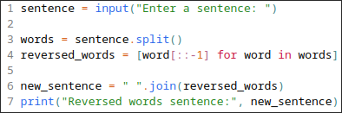

**Output:**



**Result:**

The Python Program to reverse each word in a sentence has been successfully written and executed.

**Exp. No.: 7 Date: 28.02.2025**

**DEVELOP PYTHON PROGRAMS USING LISTS, NESTED LISTS, AND LIST COMPREHENSIONS**

**7.1** – Rotating a list

Aim:

Write a Python Program to rotate a list.

Source Code:

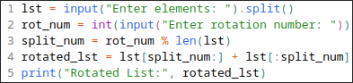

**Output:**



**Result:**

The Python Program to rotate a list has been successfully written and executed.

**7.2** – Filtering a list

Aim:

Write a Python Program to filter the words containing the letter ‘a’ from the list.

Source Code:



**Output:**



**Result:**

The Python Program to filter the words containing the letter ‘a’ from the list has been successfully written and executed.

**Exp. No.: 8 Date: 14.03.2025**

**DEVELOP PYTHON PROGRAMS USING TUPLES, NESTED TUPLES, AND TUPLE COMPREHENSION**

**8.1** – N number of minimum and maximum values

Aim:

Write a Python Program to find N number of minimum and maximum values.

Source Code:

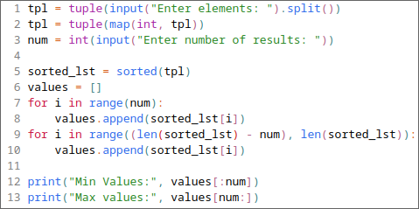

**Output:**

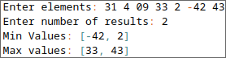

**Result:**

The Python Program to find the N number of minimum and maximum values has been successfully written and executed.

**8.2** – Flattening a nested tuple

Aim:

Write a Python Program to flatten a nested tuple.

Source Code:

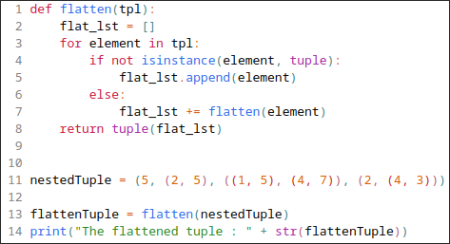

**Output:**



**Result:**

The Python Program to flatten a nested tuple has been successfully written and executed.

**Exp. No.: 9 Date: 21.03.2025**

**WRITE PYTHON PROGRAMS CREATING SETS AND PERFORMING SET OPERATIONS**

**10.1** – Common Students

Aim:

Write a Python Program to find the common students in class 1 and 2.

Source Code:

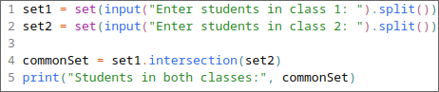

**Output:**



**Result:**

The Python Program to find the common students in class 1 and 2 has been successfully written and executed.

**9.2** – Unique Elements

Aim:

Write a Python Program to find the unique elements in a list.

Source Code:



**Output:**



**Result:**

The Python Program to find the unique elements in a list has been successfully written and executed.

**Exp. No.: 10 Date: 04.04.2025**

**DEVELOP PYTHON PROGRAMS USING DICTIONARY, NESTED DICTIONARY, AND DICTIONARY COMPREHENSION**

**10.1** – Even Squares

Aim:

Write a Python Program to store the even squares in a dictionary.

Source Code:

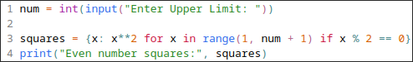

**Output:**



**Result:**

The Python Program to store the even squares in a dictionary has been successfully written and executed.

**11.2** – Top Student by Average

Aim:

Write a Python Program to find the top student by average.

Source Code:

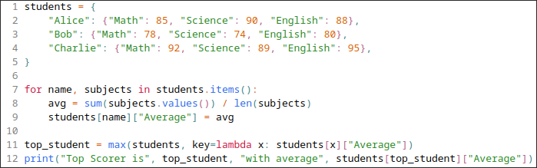

**Output:**



**Result:**

The Python Program to find the top student by average has been successfully written and executed.

**Exp. No.: 11 Date: 11.04.2025**

**DESIGN PYTHON PROGRAMS TO HANDLE ERRORS AND EXCEPTIONS**

**11.1** – Valid Input

Aim:

Write a Python Program to check if given input is valid or not.

Source Code:

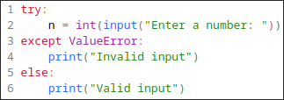

**Output:**

** **

**Result:**

The Python Program to check if given input is valid or not has been successfully written and executed.

**11.2** – Division of two numbers

Aim:

Write a Python Program to divide two numbers with error handling.

Source Code:

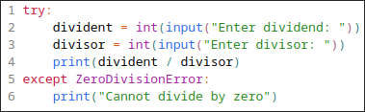

**Output:**



**Result:**

The Python Program to divide two numbers with error handling has been successfully written and executed.

**Exp. No.: 12 Date: 11.04.2025**

**DESIGN PYTHON PROGRAMS WITH MULTIPLE HANDLERS FOR EXCEPTIONS**

**12.1** – Division of two numbers

Aim:

Write a Python Program to divide two numbers with multiple exception handlers.

Source Code:

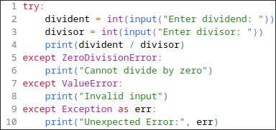

**Output:**



**Result:**

The Python Program to divide two numbers with multiple exception handlers has been successfully written and executed.

**12.2** – Square root of number

Aim:

Write a Python Program to find the square root of a number with multiple exception handlers.

Source Code:

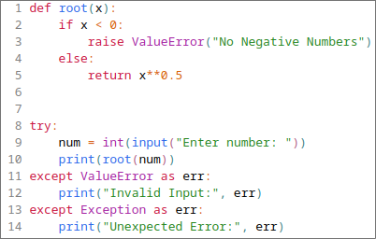

**Output:**

** **

**Result:**

The Python Program to find the square root of a number with multiple exception handlers has been successfully written and executed.

**Exp. No.: 13 Date: 25.04.2025**

**WRITE PYTHON PROGRAMS TO READ, CREATE, AND UPDATE TEXT FILES**

**13.1** – Copy one File into Another

Aim:

Write a Python Program to Copy one File into Another.

Source Code:

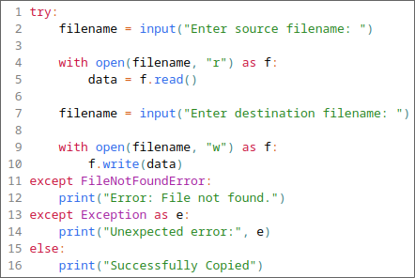

Input:

12.2.txt:

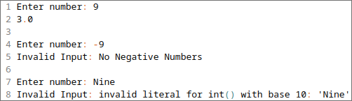

**Output:**



dest.txt:



**Result:**

The Python Program to Copy one File into Another has been successfully written and executed.

**13.2** – Count of Lines and Words in a File

Aim:

Write a Python Program to count the number of Lines and Words in a File.

Source Code:

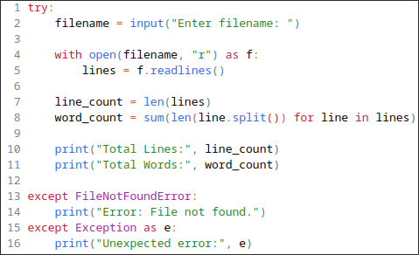

Input:

12.1.txt:

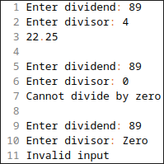

**Output:**



**Result:**

The Python Program to count the number of Lines and Words in a File has been successfully written and executed.